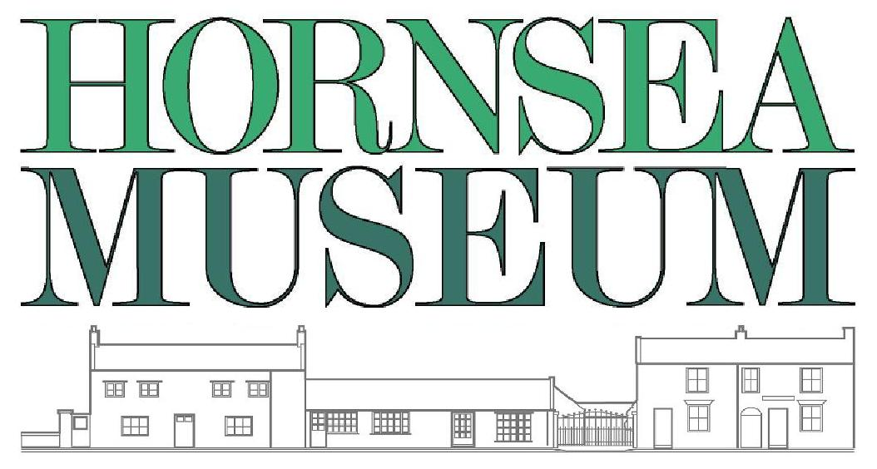
VICTORIAN ACTIVITIES BOOKING FORM
THE AIM To bring the study of domestic life in Victorian Britain to life through activities and role play.

PREPARATION We recommend a free preliminary visit for teachers who have not been to the museum.

COSTUME The visit is much more realistic when all children and adults are in Victorian costume. It helps set the mood if children can devise their own but we have plenty of items to borrow on the day. Girls should wear plain dark clothing with a white apron and mob cap or bonnet. Boys should wear trousers tucked into socks, long-sleeved shirt and dark sweater, waistcoat and cap. Please dress warmly; the museum is often colder than school.

NUMBERS We can manage a maximum of 30 children per session (more by special arrangement).
Please arrange for a minimum of 3 members of staff to be in attendance. Additional non-staff adults are also welcome.

DISCIPLINE Teachers and their assistants are responsible for ensuring good behaviour. The museum is not a playground. We ask you not to touch artefacts and exhibits without permission and supervision.

ACTIVITIES These usually include the Victorian schoolroom with ‘Mr or Miss Grimm', a close look at the Victorian kitchen with ‘Mrs Burns’, and a domestic activity such as washing with 'Mrs or Mr Scrubbitt'. Please split the children into 3 groups before the visit as this will save time on the day.

ORGANISATION There is an introductory talk to the whole group, after which you will divide into three or four groups doing each 25 minute activity in turn. This leaves time for looking around the rest of the museum and the museum shop.

DURATION We recommend a minimum of 2 hours for a visit.

PACKED LUNCHES We have a large garden for use in fine weather and very limited indoor facilities. The Parish Hall nearby is available at modest rates for lunchtime bookings. We'd be happy to provide details.

SPECIAL NEEDS We welcome children with learning difficulties and other special needs. About two thirds of the museum is accessible to visitors in wheelchairs. Please let us know if your group has any children with special needs.

TOILETS There are 2 toilets at the museum, one with wheelchair access.

MUSEUM SHOP The museum is entirely self-supporting and we therefore appreciate it very much if children are allowed to spend a little pocket money in our shop at the end of their visit.

PRICE £4.00 per child, one adult free with every 10 children, extra adults £2.00 each.
PAYMENT Please cc finance@hornseamuseum.co.uk when informing the museum that payment has been made.

CANCELLATION To cancel, we politely request notice of 1 week by email, and if this is not acknowledged, by telephone also.

Please phone Lesley on 01964 533443 for more Information.

VICTORIAN ACTIVITIES - BOOKING FORM

To book your visit please complete the sections below and email to info@hornseamuseum.co.uk
or post to Hornsea Museum, 11-17 Newbegin, Hornsea, HU18 1AB

School :
Address :
Tel No : |  | Email :
Lead Teacher : |  | Date of visit : |  |  |  | Time :
Number of Children : | Age range : |  |  |  |  | Number of Staff :
Do any of the children in the group have special needs? |  |  | Yes | No | Please specify:

