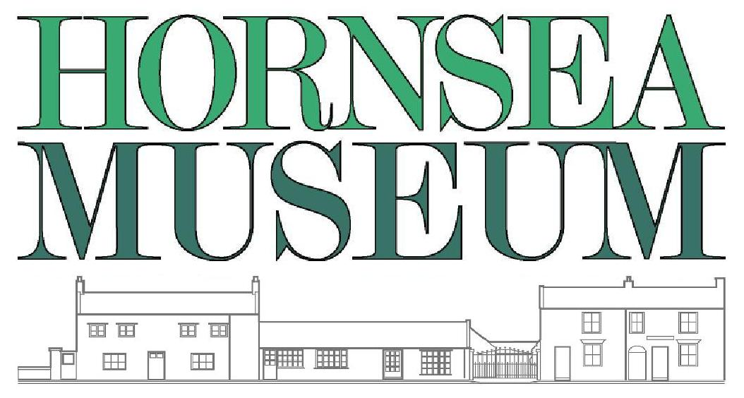School group survey

Date of visit
School name
Town

Number of children : | Number of adults :
Age range of children :

How did you hear about the museum?
Been before | Internet search | UKschooltrips.co.uk | Other

Rate activity : 1 = poor, 5 = very good
 | 1 | 2 | 3 | 4 | 5
School room
Laundry/Washhouse
Kitchen

One thing we do well :

One think we could do better :

Thank you for your comments.

Please return this form by email or post to Louise Patrick.

